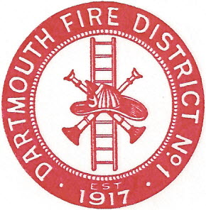
Dartmouth Fire District No.1
10 Bridge Street • Dartmouth, MA 02748
Telephone (508) 996-1596 • Fax (508) 984-4521

Agenda for November 9, 2016 @ 7:30 PM

- Vendor Warrant
- Payroll Warrant
- Approve Meeting Minutes; September 14, 2016
- Building Maintenance
- Equipment Maintenance
- Position of procurement officer
- Plans for old fire station on Bridge Street
- Adjourn

